# Human Movement Mobile Application (TrackerApp)

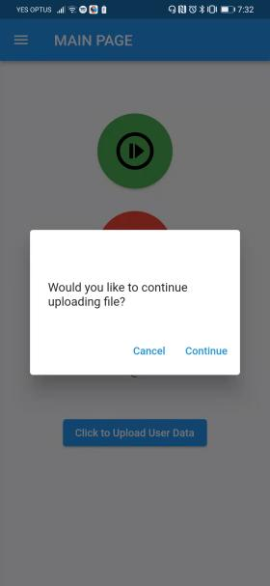

**Bug ID**: 01

**Build Number**: Version 1.001

**Priority**: HIGH

**Report By**: Weizhe Feng

**Report Date**: 18/10/2021

**Steps to Reproduce**:

1. Open “Visited Places” screen.
2. Click “Editing” button on the left center screen.
3. Process any actions such as remove & edit.
4. Back to the Home screen.
5. Click “Upload User Data” button, click “continue” or “cancel”   
   button on the pop-up dialog. The dialog does not close after finishing the process.

**Expected result:** Dialog should close after any action from the user.

**What user need to do:** Press darken area outside the dialog. If it still does not work, restart the app.

**Note for Developer:**We believe this bug is due to the flutter context’s history error. Therefore, should refactor code of “editing” screen.

_______________________________________________________________________________________

**Bug ID**: 02

**Build Number**: Version 1.001

**Priority**: HIGH

**Report By**: Weizhe Feng

**Report Date**: 01/10/2021

**Steps to Reproduce**:

1. Click “Visited Places” button to open map screen
2. Back to Home screen
3. The Status will update to “UNKNOWN”

**Expected result:** If user previous start tracking location action, the status should remain as “RUNNING” without effect by any other actions.

**What user need to do:** Press Green button to make status “RUNNING” again.

## Open issues and Future Development

1. We did not set up a server for our mobile application, instead using Firebase as our solution. This creates several risks that should be considered:
2. We lack knowledge about the success of uploading files to our cloud storage. Therefore, users do not receive any feedback from their process.
3. We must manually manage our cloud storage, instead of automating by script.
4. Clients must rely on our Firebase storage; it is risky to maintain in the future.
5. Flutter Code does not fully meet the requirement of Objective Oriented principles. We break the Open-Close principle, which may cause other developers to maintain or refactor our code.
6. Application still has problems when running on varied brands of Android devices. As some of the Android devices will kill the background process if users do not perform any action on the App.
7. We fail to fully implement all the automating testing methods, especially integrating tests for our application. This causes a lot of trouble when modifying or refactoring any old functions. We must manually test the integration of our application.
8. Speed is zero if app user run away and back to the same spot in 1 minute.
9. Make IOS version for the app in the future.

# Human Movement PC Software (Data Integrator)

**Bug ID**: D01

**Version:** Single-User Data Integrator GUI v1.0

**Priority**: HIGH

**Report By**: Han

**Report Date**: 17/10/2021

**Steps to Reproduce**:

1. Click “Load Files” button to select wanted files
2. Click “Load Files” button to select the same files again.

3. The GUI will crash

**Expected result:** User should not allow to select the same files again.

**What user need to do:** Avoid choosing the same file twice.

## Open issues and Future Development

1. Issues: User should be able to unselect selected files
2. Future Development: Make software workable in Windows OS in the future.
3. Future Development: Build GUI for Multi-user Data Integrator or enable Multi-user feature GUI.
4. Future Development: Check and report anomalies more thoroughly.